**Traffic Light Controller Implementation**

Distributed control systems

**Project professor:** Dahlia Al-Janabi

**Team**: Team 6

**Team members:**

Gruia Sergiu-Dimitrie

Brezae Tudor

Dutkas Alexis-Andrei

Diaconu Paul-Costin

Contents

Maps 3

Petri Net Design 5

Types 5

Guards 6

Mappings 6

Controller Design 7

Types 8

Guards and Mappings 8

Component Diagram 10

Implementation 10

# Maps

For this project we were assigned 2 intersections from Cluj-Napoca, Romania, as seen in Figure 1. First Intersection and Figure 2.

Figure 1. First Intersection

Figure 2. Second Intersection

For these we took the directions as seen in Figure 3. Road Directions Overlay

Figure 3. Road Directions Overlay

Present as well in Figure 4. Simplified Road Directions in a simplified version.

Figure 4. Simplified Road Directions

# Petri Net Design

We then modeled the intersection using Petri Nets:

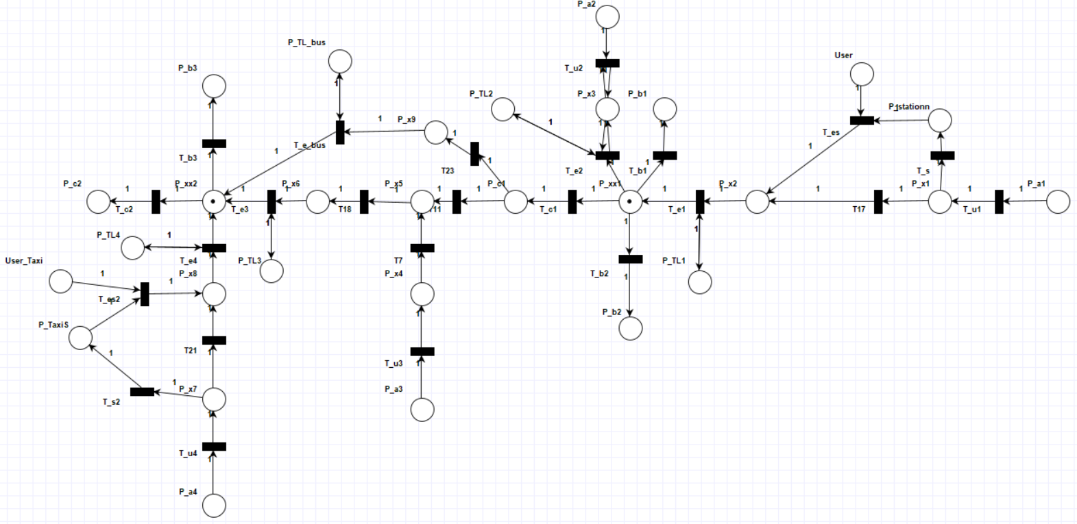

For which we have the following:

## **Types**

Type(P_a1) = Type(P_a2) = Type(P_a3) = Type(P_a4) = **DataCar()** // *inputs of the lanes*

Type(P_b1) = Type(P_b2) = Type(P_b3) = **DataCar()** // *outputs of the lanes*

Type(P_c1) = Type(P_c2) = **DataCar()** // *outputs of the intersection*

Type(P_x1) = Type(P_x2) = Type(P_x3) = Type(P_x4) = Type(P_x5) = Type(P_x6) = Type(P_x7) = Type(P_x8) = **DataCarQueue()** // *intersection inputs represented as queues*

Type(P_x9) = **DataCarQueue()** // *intersection input represented as queue for bus lane*

Type(P_station) = Type(P_taxi_station) = **DataCarQueue** // *intersection inputs as queues for taxi and bus*

Type(OP1) = Type(OP1) = Type(OP1) = Type(OP1) = DataTransfer()

Type(P_TL1) = Type(P_TL2) = Type(P_TL3) = Type(P_TL4) = Type(P_TL_BUS) = **DataString()** // *traffic lights*

Type(P_xx1) = Type(P_xx2) = **DataCarQueue()** // *intersections*

Type(User) = Type(User_taxi) = **DataString()** // *human input*

## **Guards and Mappings**

**Right Intersection**

T_u1:

Grd = (P_a1!=NULL && P_x1.CanAddCars && P_a1.IsBus)

Map = P_a1.addElement(P_x1)

T_s:

Grd = (P_x1.HaveCarForMe && ( P_x1.isPriorityCar || P_x1.haveBus))

Map = P_x1.addElement(P_station)

T_es:

Grd = (user !=NULL && P_station.haveBus)

Input = ArrayList<string>.add -> P_station

-> user

Map = (input, P_station.PopBusToQueue(P_x2) )

T17:

Grd = (P_x1 != NULL)

Map = P_x1.addElement(P_x2)

T_e1:

Grd = (P_x2.HaveCarForMe && P_TL1==”Green”)

Map = P_x2.PopElementWithoutTarget (P_xx1)

T_b1:

Grd = (P_xx1.HaveCarForMe)

Map = P_xx1.PopElementWithTarget(P_b1)

T_b2:

Grd = (P_xx1.HaveCarForMe)

Map = P_xx1. PopElementWithTarget (P_b2)

T_e2:

Grd = (P_x3.HaveCarForMe && P_TL2==”Green”)

Map = P_x3.PopElementWithoutTarget (P_xx1)

T_u2:

Grd = (P_a2.HaveCarForMe)

Map = P_a2.addElement(P_x3)

T_c1:

Grd = (P_xx1.HaveCarForMe)

Map = P_xx1. PopElementWithTarget (P_c1)

**Left Intersection**

T23:

Grd = (P_c1.HaveCarForMe && ( P_c1.isPriorityCar || P_c1.haveBus))

Map = P_c1.addElement(P_x9)

T_e_bus:

Grd = (P_x9.haveBus && P_TL_BUS==”Green”)

Map = P_x9.PopElementWithoutTarget (P_xx2)

T_u3:

Grd = (P_a3.HaveCarForMe)

Map = P_a3.addElement(P_x4)

T7:

Grd = (P_x4 != NULL)

Map = P_x4.addElement(P_x5)

T11:

Grd = (P_c1 != NULL)

Map = P_c1.addElement(P_x5)

T18:

Grd = (P_x5 != NULL)

Map = P_x5.addElement(P_x6)

T_e3:

Grd = (P_x6.HaveCarForMe && P_TL3==”Green”)

Map = P_x6.PopElementWithoutTarget (P_xx2)

T_u4:

Grd = (P_a4.HaveCarForMe)

Map = P_a4.addElement(P_x7)

T21:

Grd = (P_x7 != NULL)

Map = P_x7.addElement(P_x8)

T_e4:

Grd = (P_x8.HaveCarForMe && P_TL4==”Green”)

Map = P_x8.PopElementWithoutTarget (P_xx2)

T_c2:

Grd = (P_xx2.HaveCarForMe)

Map = P_xx2.PopElementWithTarget(P_c2)

T_s2:

Grd = (P_x7.HaveCarForMe && ( P_x7.isPriorityCar || P_x7.haveBus))

Map = P_x7.addElement(P_taxi_station)

T_es2:

Grd = (user_taxi !=NULL && P_taxi_station.HaveCarForMe)

Input = ArrayList<string>.add -> P_taxi_station

-> user_taxi

Map = (input, P_taxi_station.PopTaxiToQueue(P_x8))

Tout1:

Grd = (P_x1 != NULL && P_x2.CanNotAddCars)

Map = OP.SendOverNetwork(“Full”)

Tout2:

Grd = (P_a2 != NULL && P_x3.CanNotAddCars)

Map = OP.SendOverNetwork(“Full”)

Tout3:

Grd = (P_x5 != NULL && P_x6.CanNotAddCars)

Map = OP.SendOverNetwork(“Full”)

Tout4:

Grd = (P_x7 != NULL && P_x8.CanNotAddCars)

Map = OP.SendOverNetwork(“Full”)

# Controller Design

For which we have the following:

## **Types**

Type(r1r2r3r4r5) = Type(g1r2r3r4r5) = Type(y1r2r3r4r5) = Type(r1g2r3r4r5) = Type(r1y2r3r4r5) = Type(r1r2g3r4r5) = Type(r1r2y3r4r5) = Type(r1r2y3r4r5) = Type(r1r2r3g4g5)= **DataString()**

Type(OP1) = Type(OP2) = Type(OP3) = Type(OP4) = Type(OP_Bus) = **DataTransfer()**

## **Guards and Mappings**

T1:

Grd = (r1r2r3r4r5 != NULL)

Map1 = r1r2r3r4r5.Move(g1r2r3r4r5)

Map2 = green.SendOverNetwork(OP1)

T2:

Grd = (g1r2r3r4r5 != NULL)

Map1 = g1r2r3r4r5.Move(y1r2r3r4r5)

Map2 = yellow.SendOverNetwork(OP1)

T3:

Grd = (y1r2r3r4r5 != NULL)

Map1 = y1r2r3r4r5.Move(r1g2r3r4r5)

Map2 = red.SendOverNetwork(OP1)

Map3 = green.SendOverNetwork(OP2)

T4:

Grd = (r1g2r3r4r5 != NULL)

Map1 = r1g2r3r4r5.Move(r1y2r3r4r5)

Map2 = yellow.SendOverNetwork(OP2)

T5:

Grd = (r1y2r3r4r5!= NULL)

Map1 = r1y2r3r4r5.Move(r1r2g3r4r5)

Map2 = red.SendOverNetwork(OP2)

Map3 = green.SendOverNetwork(OP3)

T6:

Grd = (r1r2g3r4r5 != NULL)

Map1 = r1r2g3r4r5.Move(r1r2y3r4r5)

Map2 = yellow.SendOverNetwork(OP3)

T7:

Grd = (r1r2y3r4r5 != NULL)

Map1 = r1r2y3r4r5.Move(r1r2r3g4g5)

Map2 = red.SendOverNetwork(OP3)

Map3 = green.SendOverNetwork(OP4)

Map4 = green.SendOverNetwork(OP_Bus)

T8:

Grd = (r1r2r3g4g5 != NULL)

Map1 = r1r2r3g4g5.Move(r1r2r3y4y5)

Map2 = yellow.SendOverNetwork(OP4)

Map3 = yellow.SendOverNetwork(OP_Bus)

T9:

Grd = (r1r2r3y4y5 != NULL)

Map1 = r1r2r3y4y5.Move(r1r2r3r4r5)

Map2 = red.SendOverNetwork(OP4)

Map3 = red.SendOverNetwork(OP_Bus)